TryHackMe Room Report: Windows Basics
Week: 2
Topic: Windows Fundamentals and Windows Logging
Platform: TryHackMe
Date Completed: 26 October 2026
1. Objective
The objective of this exercise was to understand the fundamentals of the Windows operating system, learn basic Windows administration concepts, and explore important tools and features used in system management and cybersecurity.
2. Concepts Learned
- Windows operating system fundamentals
- Windows desktop and file system
- Files, folders, and file extensions
- User accounts and permissions
- Task Manager and running processes
- Control Panel and system settings
- Command Prompt basics
- Windows security and system administration
3. Tasks Performed
- Explored the Windows desktop and basic operating system interface.
- Reviewed files, folders, directories, and file extensions.
- Learned about Windows user accounts and permissions.
- Explored Task Manager to understand running applications and processes.
- Reviewed basic Windows administration tools and system settings.
- Learned how Windows system knowledge supports endpoint monitoring and security investigations.
4. Commands Used
Command 1: Display the current directory
cd
Explanation: Displays the current working directory in Command Prompt.
Command 2: List files and directories
dir
Explanation: Displays the files and folders in the current directory.
Command 3: Display system information
systeminfo
Explanation: Displays Windows system details, including operating system information, system configuration, and installed updates.
Command 4: Display network configuration
ipconfig
Explanation: Displays network configuration details such as IP addresses, subnet masks, and default gateways.
Command 5: Display running processes
tasklist
Explanation: Lists running processes on the Windows system.
5. Findings and Observations
- Windows provides built-in tools for managing files, users, applications, and system settings.
- Task Manager helps users inspect running applications and processes.
- Command Prompt provides commands for examining system and network information.
- User permissions help control access to files, applications, and system resources.
- Understanding normal Windows activity helps identify potentially suspicious behavior.
- SOC Analysts can use Windows knowledge when investigating unusual processes, unauthorized access, and endpoint security alerts.
6. Screenshot
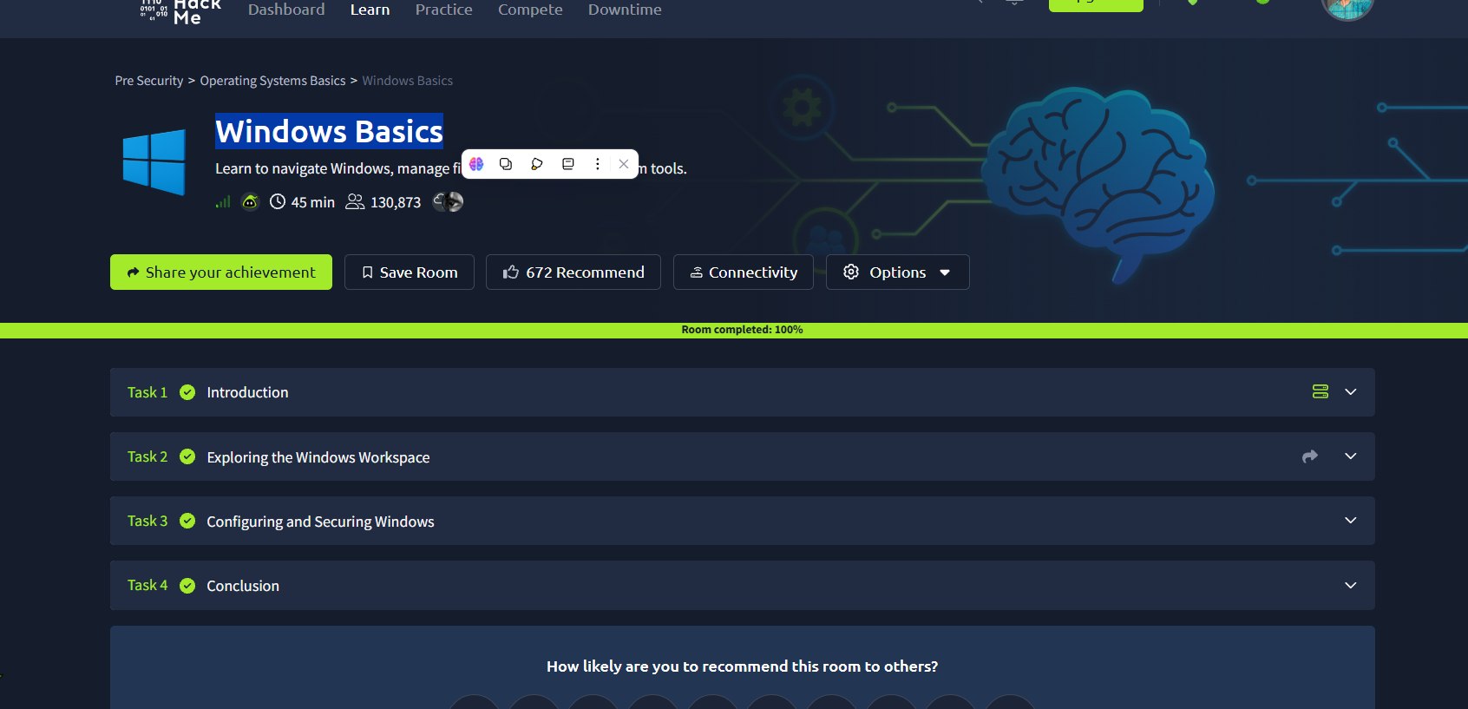Caption: Successfully completed the Windows Basics exercise and reviewed fundamental Windows operating system features.
7. Challenges Faced
The main learning challenge was understanding the purpose of different Windows administration tools and how command-line utilities help inspect system information.
8. Conclusion
This exercise helped me understand Windows operating system fundamentals, system administration tools, user permissions, and basic command-line operations. These skills provide a foundation for Windows event log analysis, endpoint monitoring, and SOC investigations.

